**NCAA Basketball prediction Dashboards**

1. **Teams Ids in Seed**:

Number of times, Any team in Seed "W".

Number of times, Any team in Seed "X".

Number of times, Any team in Seed "Y".

Number of times, Any team in Seed "Z".

The seed can be defined same as a 'walkover' given to the team that has performed well in the same competition in

the previous session. It is being done to prevent the conflict of the two good teams in the preliminary rounds and

spoil the level of competition. The team that has won the tournament last year is kept at the bottom of the fixture,

the runner up at the top, then the semifinalists in the middle of the list and so on.

This is just to organise the healthy competetion in the higher levels of the tournament between the better teams.

* 1. Team Ids in Seed “W”

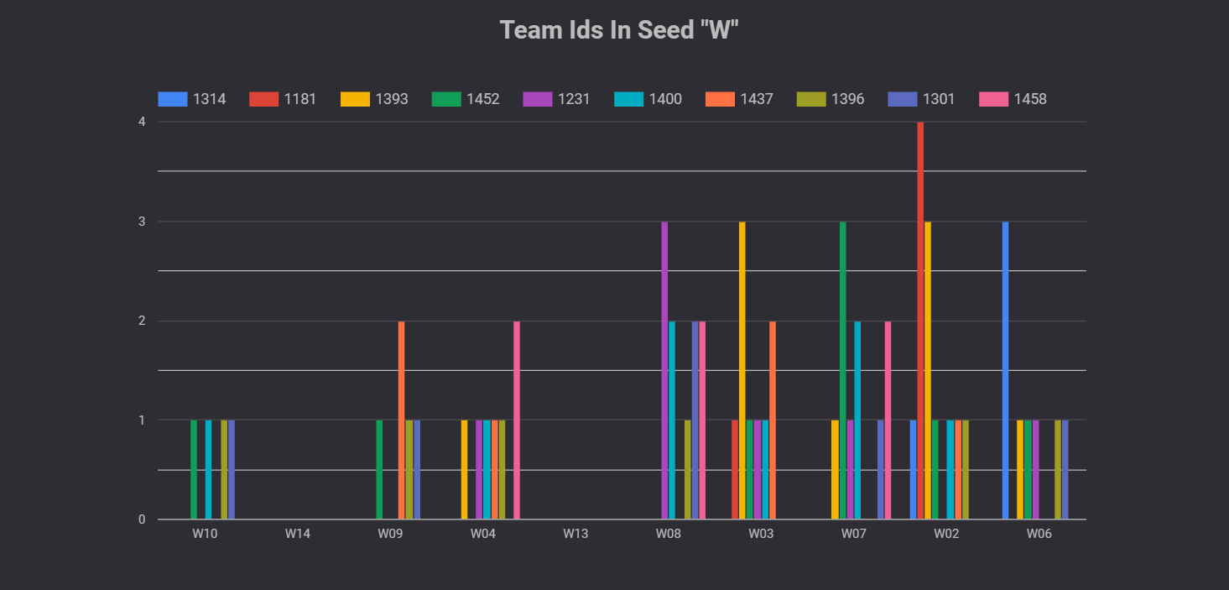

* 1. Team Ids in Seed “X”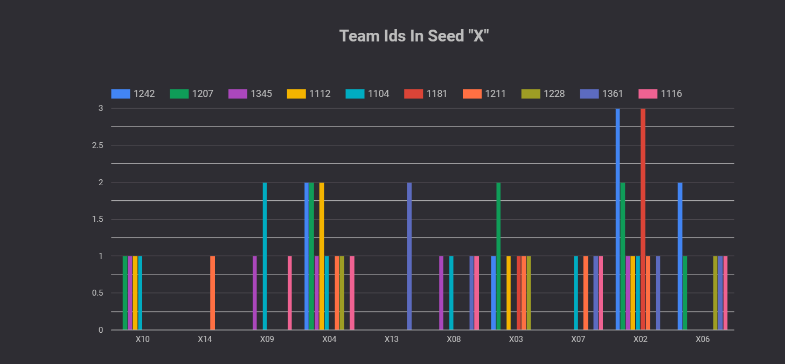
  2. Teams Ids in Seed “Y”

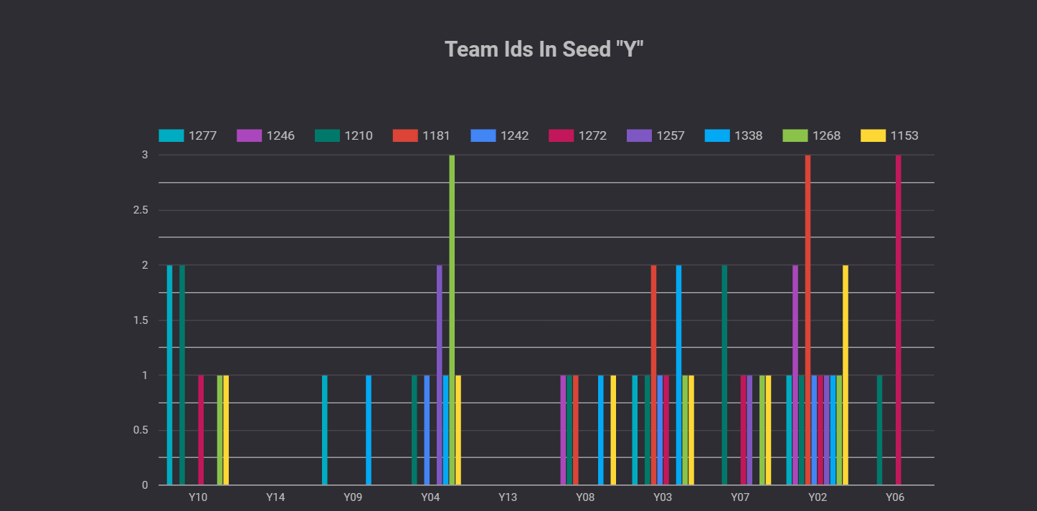

* 1. Team Ids in Seed “Z”

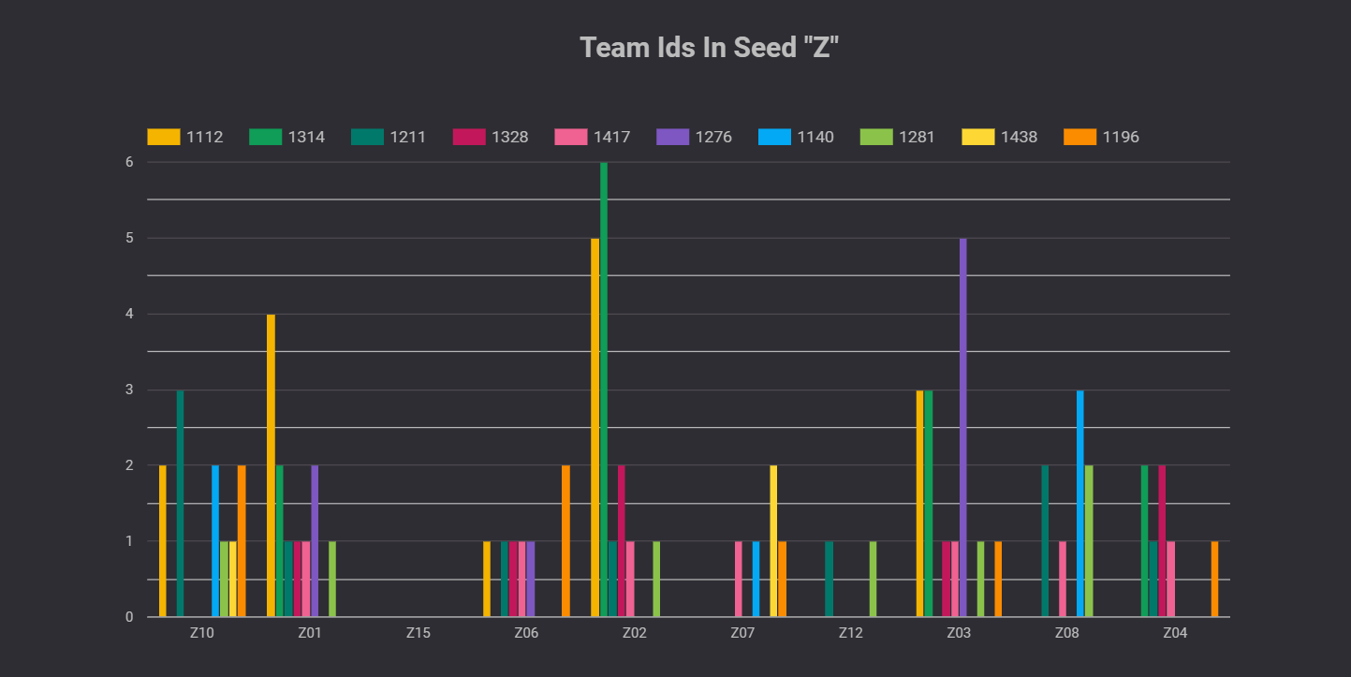

1. **Basketball Award Details**:

From this table, we can find out which team has won NCAATournment and NCAAChampion

as well which player has won NaismithAward and WoodenAward in every season.

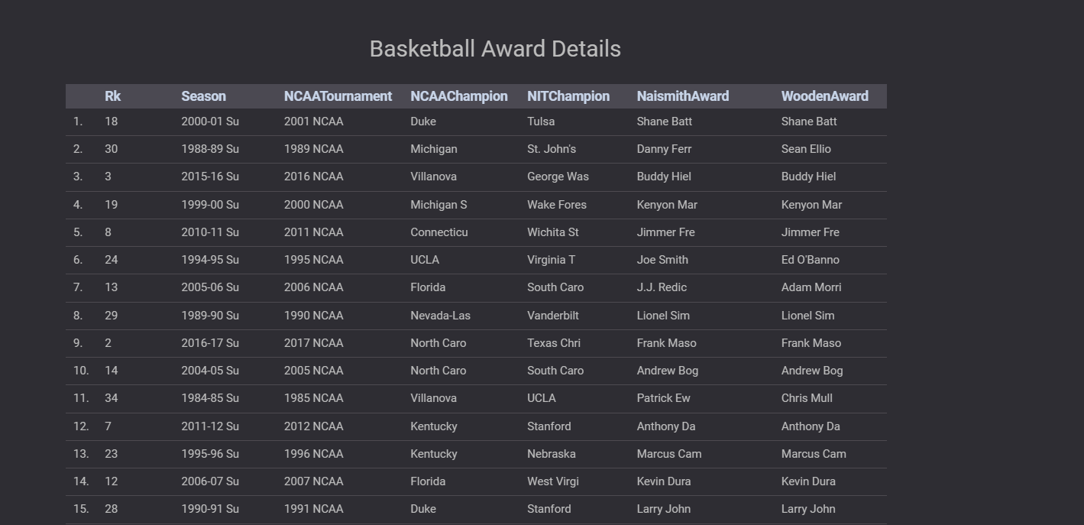

1. **Team ID wise Winning Losing Score**:

This graph is related to the Season wise all matches and final scores.

Using this graph we can find out which team has won against which team and vice-versa in all the seasons. We can also use this to find out the favorite team for all the future matches.

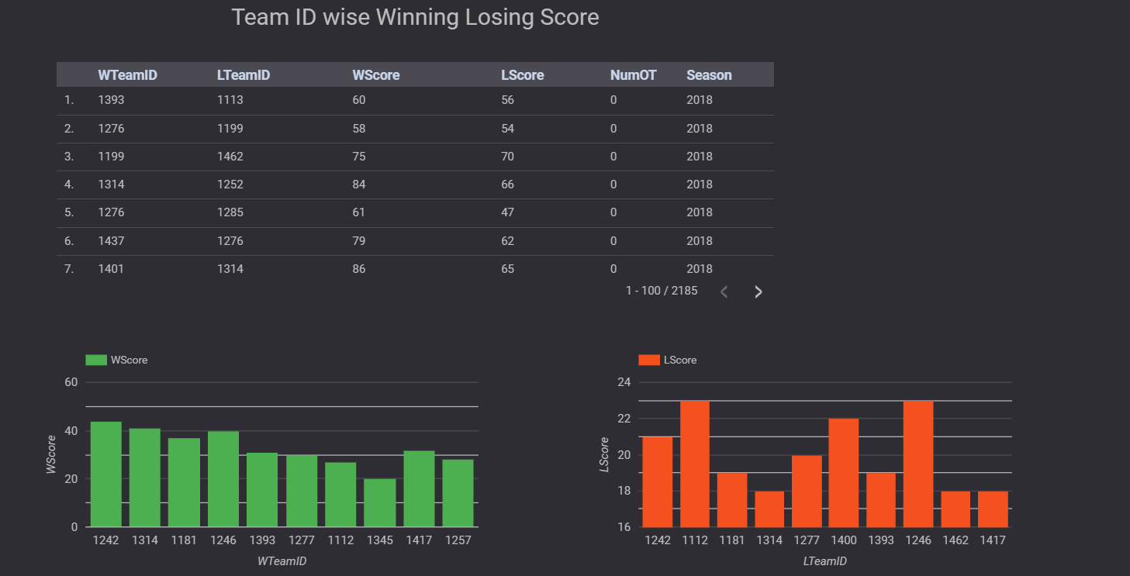

1. **Winning/ Loosing overall score over the seasons**:

The first bar chart shows the winning and loosing score for all the seasons. This helps to analyze the overall score consistency and gives a good idea for next season to set a baseline for winning the matches of the season.

The pie chart shows the no of overtime periods overtime the season. The overtime analysis helps to understand matches that exceeded the dedicated time. This helps one plan for the next season accordingly

